Health Needs and Preferences: How well does BMC Dining Services Respond?
By Chloe Lampros-Monroe

Students come to Bryn Mawr from a variety of different backgrounds, both domestic and international, bringing with them their own food cultures and preferences. Some students have extra concerns, needing to follow a diet that is vegan, vegetarian, or gluten free, as well as other dietary restrictions revolving around religion, such as the need for kosher/halal options. Students often have many concerns about health, especially after transitioning to a different environment. According to Sarah E. Gores, a registered nurse and family nurse practitioner, “as young adults move into an independent living situation, there is a high risk for unhealthy eating habits” (Gores, 2008), a fact that makes this issue especially important. On its website Bryn Mawr advertises that is ranked in the Top #10 for Campus Food by the Princeton Review, and that it was given a grade of A on the Peta2 Vegan Report Card (“About US: Award & Recognition,” 2017). How well does the Bryn Mawr dining hall respond to student needs? I conducted interviews with ten students to find out the scoop.
Overall, students felt that the dining hall tried to be accommodating of students with dietary restrictions. An anonymous student (class of 2020) sad that she is allergic to tree-nuts, and that the dining center has been very accommodating. However, she does wish that they would have more vegetarian options that don’t involve fake meat. Katie, class of 2017 is vegetarian, and feels that the dining hall does a good job of making sure that there are lots of options for vegetarians. In her interview, she mentioned that there is usually a main entrée that is designated as vegetarian. Another student (Anonymous, class of 2017) has no dietary restrictions herself, but feels that vegetarian/vegan options seem to be significant at BMC. However, she has heard that for people who do have religious dietary restrictions, their food options are extremely limited and sometimes prepackaged. Another student, Anonymous, class of 2019, mentioned that there are a lot of vegan options, and they mark it well. However, she remarked that finding options in the dining hall may be harder for students who are gluten free. While the chef usually makes something special for gluten free people, she feels that usually the options are very limited, and that people who eat gluten free have a lot of choices. Van, class of 2017, also mentioned that they do a good job with labeling in the dining hall. It seems that, in general the dining hall does a good job of accommodating students who are vegan and vegetarian, but that they could have more options for students with more restrictive diets. As none of the students I interviewed had religious dietary restrictions, I would need to interview more students with these kinds of dietary needs in order to really find out how they fare in the BMC dining foodscape.
In terms of the health of food, students generally agreed that that the dining hall tried to provide a good amount of options, although some felt that the food was high in fat. Some students spoke specifically about the high amount of salt and fat in their diets, and about a general decrease in their health since they came to Bryn Mawr. Yuwei, class of 2018, salt that the food ends to be salty and greasy. Another student, Princy (class of 2019), agreed, saying that she feels that the hot food is often oily and fatty, and that she’s become less healthy since coming to BMC. Another student, Anonymous Student, class of 2019, also mentioned that some of the food is too oily. However, students also mentioned that overall the dining hall provides a good amount of variety, and that it provides a good variety of both healthy and unhealthy choices. An anonymous student (class of 2017) thinks that the food’s okay, and that it is fairly good health wise. She also mentioned that they provide both healthy choices and unhealthy choices, and that they are “above par” compared to other college campuses. Van, class of 2017, agrees. She thinks BMC Dining Services provide healthy options but also very tempting and unhealthy options. Another student, anonymous class of 2017, also feels that the dining hall provides a significant amount of variety. She mentioned that every meal at lunch and dinner, they try to provide all of the food groups in terms of proteins, vitamins, etc.
About half of the students that I interviewed were international, and a common thread was that there was a period of adjustment. In her interview, Yuwei, an international student from China, mentioned that while she is grateful for the Chinese bar that they currently offer in the dining hall, the Chinese food that she was used to was very different from what they had in the dining hall, which is something to be expected when the dining hall offers international foods. Another international student from China, anonymous student class of 2019, feels that sometimes there is nothing to eat, since she prefers Asian food more and there are not many choices. Another international student (Anonymous class of 2017) mentioned that at first she wasn’t used to the food here, and wasn’t eating very much at first since it took her awhile to adapt to the tastes of different foods. However, she also mentioned that they try to balance the food groups and provide a variety of things, and that overall she is now happy with the food here.
After interviewing these students, what can we learn about the foodscape in the Bryn Mawr dining halls? Bryn Mawr seems to overall does a good job of trying to accommodate students, especially vegetarians, but could consider developing more options for students with other restrictions that are harder to accommodate. The Bryn Mawr dining hall provides a good variety, but could also cut down on oily and fatty foods. In addition, a common theme mentioned by these students was that they really enjoy the special themed meals. Periodically, the Bryn Mawr dining hall has meals that revolve around certain themes, such as Soul Food and Spring Hummus Dip. One student, Van, class of 2017, said that these kinds of events “make eating not just about food but also about culture. Another student mentioned that she hopes dining services has more of these kinds of meals in the future. This article only looks at a small sample of Bryn Mawr students, and to find out more about the Bryn Mawr foodscape, more interviews would need to be conducted. While Bryn Mawr Dining Services could do more to accommodate students with special needs, they seem to have earned their top rankings and do a good job of accommodating vegans and vegetarians.
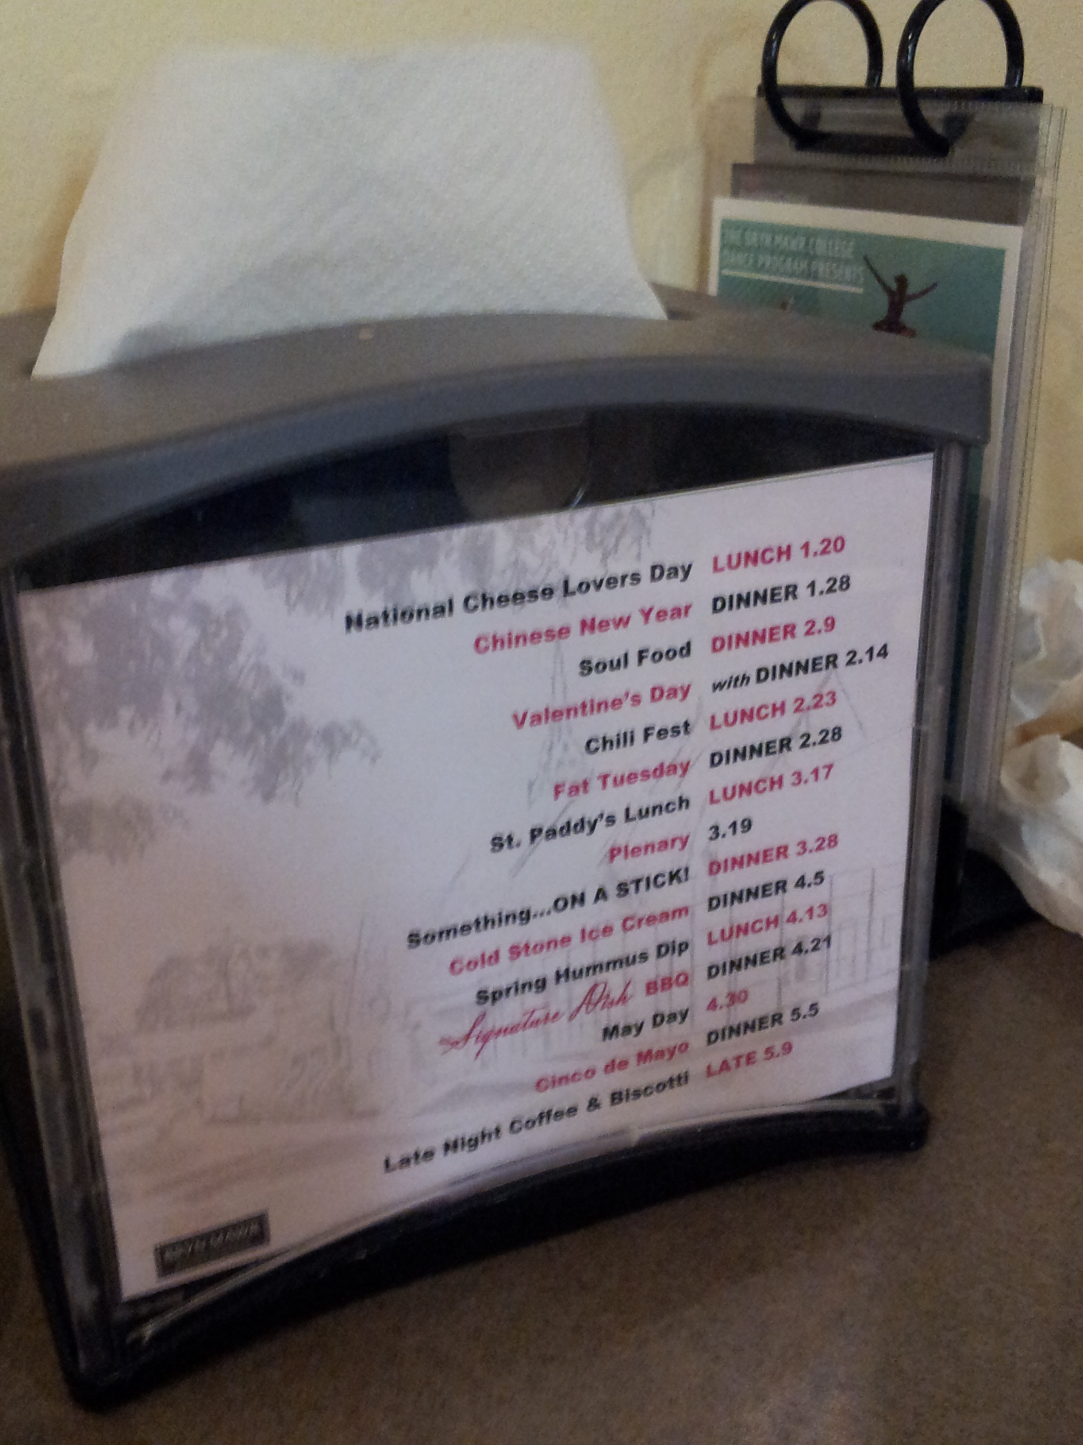
Left: Calendar of special meals on one of the napkin holders in Erdman, one of Bryn Mawr’s dining halls. Special meals were very well liked by interviewed students.

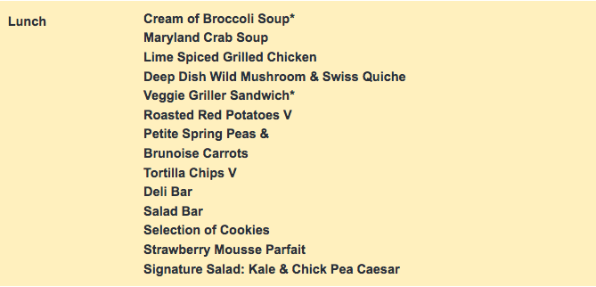
Above: The online (mobile friendly) version of one of the Erdman lunch menus. Items marked with a * are vegetarian, and items marked with V are vegan.

References

About Us: Rewards & Recognition. (2017). Retrieved April 28, 2017, from http://www.brynmawr.edu/dining/about/awards.html
Gores, S. E. (2008). Addressing nutritional issues in the college‐aged client: Strategies for the nurse practitioner. Journal of the American Academy of Nurse Practitioners, 20(1), 5–10. https://doi.org/10.1111/j.1745-7599.2007.00273.x

