Are Haverford Students Victims of Food Injustice?

In a survey of Haverford College students, I discovered that 77.78% of respondents said that their diet while at school is less healthy than the one they have at home. Since the Dining Center is the main space on campus to obtain food, it can be assumed that the DC is the primary source of this discrepancy. While some students live in the apartments and students sometimes pay for meals in the COOP or off-campus, the majority of students eat the bulk of their meals at the DC. At Haverford there are two meal plans: Traditional and Black Squirrel. The Traditional meal plan comes with unlimited access to the DC and Bryn Mawr dining halls and $50 dining dollars a semester. The Black Squirrel meal plan comes with $25 dining dollars a semester, 20 meals per week at the DC or Bryn Mawr dining halls, and 25 meal equivalencies at the COOP per semester. Clearly, on both meal plans, the DC is the primary source of food unless Haverford students are going to travel to Bryn Mawr or spend money on outside food. Very few students at Haverford travel to Bryn Mawr to eat - unless they have class - with any frequency. So, I think the question is whether the difference in home and school diets are a result of students’ poor choices or if there is a lack of availability of healthy options, making this a food injustice as well as a case of food insecurity (Smith).

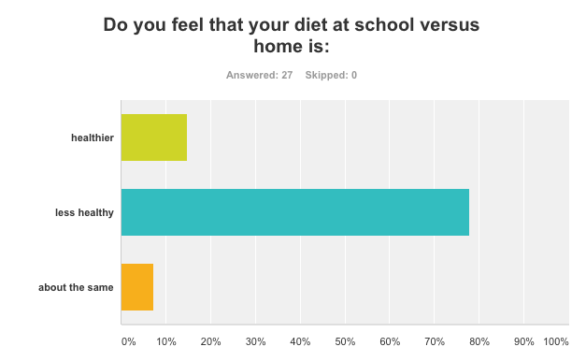

Food justice is typically understood to mean that everyone has access to safe, healthy, and culturally appropriate food (Whyte 123). One aspect of this norm that is frequently discussed on Haverford College’s campus is the availability of healthy food, or more specifically the lack thereof. This is the one aspect of food justice that Haverford College students seem to feel the Dining Center violates. While 70% of respondents answered that they felt that the DC offered culturally appropriate food options, only 37.04% responded that they feel that the campus has a sufficient amount of healthy options (Smith). Since, as established above, the DC is the primary place for food on campus, it can be assumed that these survey results are indicative of the options at the DC.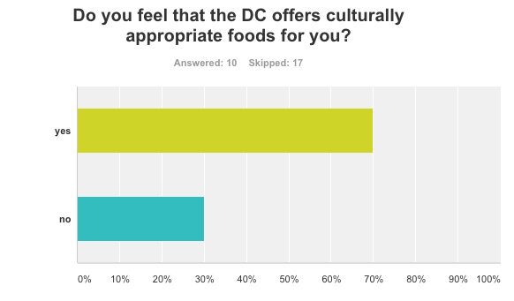

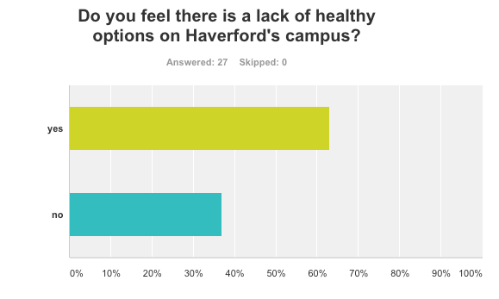

Further, food security is defined as having consistent access to a sufficient quantity of affordable nutritious food (Noll). Therefore, according to the survey information, students at Haverford overwhelmingly feel that they do not have access to healthy and nutritious food in the DC. This makes students food insecure, because unless they are going to consistently purchase food from the COOP or off-campus, they are stuck with unhealthy meals. Therefore, the DC is, by definition, violating students’ food security by making the only truly affordable food on campus unhealthy and lacking nutrition.
This issue of healthy food in the DC is compounded by the fact that respondents seem to feel that the few healthy options that do exist in the DC are less accessible than the less healthy options. In fact, 77.78% of respondents answered that they are more likely to grab the convenient - albeit less healthy - options than spend the time to create something healthier (Smith). With the busy schedules that students keep at Haverford, it is not surprising that they will grab the quickest and most convenient food option as opposed to the healthiest option that takes time to prepare. Further, creating healthy food options takes ingenuity and a lot of effort to put these meals together. And finally, the few healthy options and ingredients that do exist tend to be the same everyday, leaving very little variety for those creative enough and willing to put in the effort to create healthier meals.

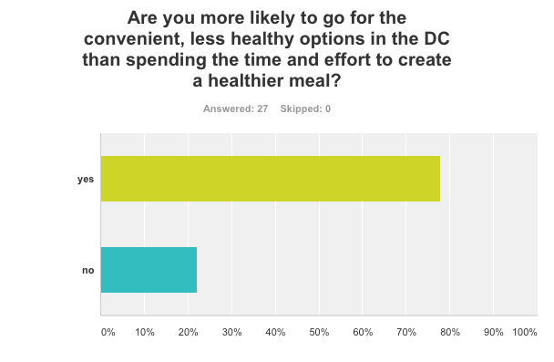

When asked for the specific differences between their home and school diets, many respondents had similar answers. Many students expressed that they eat more fruits, yogurt and vegetables at home because there is little variety in the DC in this regard and the options that do exist tend to be low quality. The other common thread was increased meat and protein consumption at home, since again there are very few healthy protein options in the DC and many students “don’t trust” the meat prepared by the DC. Also mentioned by many respondents was that individuals eat less carbs at home because at the DC they are one of the few things that are “safe”. Finally, the most stated difference is that there are far fewer healthy options at school than there are at home. Ultimately, it appears the common theme is the limiting options at the DC and the low quality of the food, making it undesirable (Smith).
So, going back to the original question, it appears that there is in fact a lack of healthy food options in the DC and the few that exist are much harder to come by or low quality. While this may not be a serious form of food injustice or forced food insecurity, I do think that in many ways this is a minor food injustice, which is making students food insecure. The DC is the primary source of meals for Haverford College students, as shown by the two meal plans available. Therefore, the fact that students feel that there are too few healthy options in the DC and that the few options that do exist are more difficult to come by and require significantly more time and creativity or are low quality and unappealing, seems to be a mild form of food injustice. Of course, there is an element of students being unwilling to put in the time and effort to create the healthier options; however, that is understandable with the busy schedules students keep and the creativity required to make these healthy meals. Regardless, there is still the fact that students feel there are not enough healthy options in the DC and those that exist are much more inconvenient. Finally, while there are other options for Haverford students such as going to Bryn Mawr or spending money off campus or at the COOP or at Lunt, these options are far less available and accessible to Haverford students as the DC.

Ways to Get Creative in the DC (Healthier options)

Here are some options that are not only more nutritious than many readily-available options in the DC, but also lower in calories and do not take a lot of time!

Balsamic Chicken Flatbread: Place grilled chicken pieces (1 piece of chicken), shredded mozzarella or cheddar cheese (1/5 cup), spinach (1/3 cup), and balsamic vinegar (1 tablespoon) in between slices of pita bread and use the panini press to melt it all together and make it crispy. Calories: 317

Grilled Chicken Sandwich: Toast two slices of wheat bread, place a slice of american cheese, grilled chicken (1 piece), and ketchup on the sandwich. Calories: 230

Chicken Caesar Salad: Romain lettuce (3 cups), mozzarella cheese (1/4 cup), croutons (1/4 cup), grilled chicken (1/4 cup) and Caesar dressing (1/4 cup). Calories: 585

Waldorf Salad: Romain lettuce (3 cups), cheddar cheese (1/4 cup), dried cranberries (1/5 cup), pecans (1/5 cup), apple slices (1/2 apple), balsamic vinaigrette (1/4 cup). Calories: 616

Tuna Melt: Slice up the cherry tomatoes at the salad bar (6 tomatoes), place them in between two slices of toasted wheat bread with tuna salad (2 tablespoons) and american cheese and put it in the panini press. Calories: 509

Chicken Quesadilla: Put shredded cheddar cheese (1/2 cup) and grilled chicken (1 piece) in a tortilla and put it in the panini press. Calories: 420

Chicken Salad Sandwich: Toast two slices of wheat bread, then place a slice of american cheese and chicken salad (1/4) on the toast. Calories: 434 (MyFitnessPal)

Bibliography:

MyFitnessPal. Computer Software. Apple App Store. Vers. 7.13.1. MyFitnessPal LLC, 2017.

Noll, Samantha. Lecture. Food Bioethics: The Ethics, Justice, and Human Rights of Food Choice. Haverford College, Haverford, PA. Feb-Apr 2017.

Powys White, Kyle, “Food Justice and Collective Food Relations.” Food, Ethics, and Society (2017): n. pag, Text.

Smith, Noelle. “Food Bioethics Survey” Survey. SurveyMonkey. SurveyMonkey, 19. Apr. 2017

